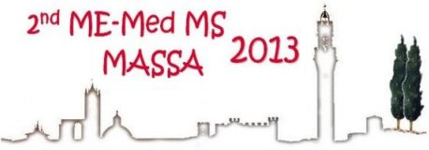
SIENA (Italy), June 30 – July 4, 2013

REGISTRATION FORM

Please complete this form and return it by e-mail or fax to:
University of Siena - Congress Office
Via San Vigilio, 6 - 53100 Siena (Italy)
Tel. +39-0577-232132 fax +39-0577-232134
E-mail: servcong@unisi.it

Prof./Dr/ (Surname): (Name):
University/Company:
Zip ____________ City
State: __________ Tel: ___________ Fax: ___________ E-mail:
Registration fees (include n. 3 lunches, refreshments, program portfolio, book of abstracts)
before after Amount
April 30, 2013 April 30, 2013 to be paid
❑ Regular Euro 180.00 Euro 210.00 Euro ____________
❑ Students* Euro 80.00 Euro 110.00 Euro ____________
* Certification of student status together with the registration form is required.

Payment can be made by:
❑ Cheque issued to: SCI- Division of Mass Spectrometry
❑ Bank transfer to:
Bank name: CR Firenze
Bank address: viale Cavour, 70 - 53100 Siena (Italy)
IBAN: IT35 U061 6014 2066 2502 0908 719
BIC/SWIFT: CRFIIT3F

The receipt should be addressed to:

Special requests:

Date __________________________ Signature__________________________________

Information concerning the protection of privacy and the processing and utilization of personal data
In accordance with law 675, passed on Dec. 31, 1996, we wish to inform you that the personal data you furnished in filling out the registration form for enrolment in this workshop will be used exclusively for enrolment purposes. In processing this information we guarantee that your privacy will not be violated and that this data will not be given or communicated to third parties. Failure to furnish information will entail no consequences, as you are not required to provide in. With regards to the utilization of this data, your rights are protected by art. 13 of law 675/96.

